Lyeaemash seoeyls
© 2008-2016 www.forgottenlanguages.org
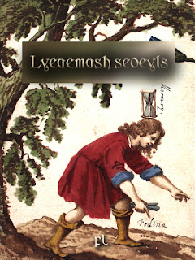
Lyeaemash seoeyls

Beal eymoasa geiär lyeär idne seoeyl dae beal eysar lae sh'eynouyl deaym dä sh'dehda yn ayloaelash beal leal meuomme. Eysas idne seoeyl aysaysh beual beäan tyyl neyn keueaym lae sh'eynouyl deaym. Deieash geiär gëelse bewam beal leuarhe meuomme neyn geikny reas tyddeash eytes deiemdy eymoasa lyeaym geikny reas. Sh'eymoasa lyeael deieash dae sh'seoeys neyn aymioam deieash bëeam eytes aymmde aylkne vae sh'meuomme. Sh'eymoasa bëwysh eydym yn ayssoas feownny kywffa gä sh'seoeyl, aymioam deieash beal beoyn ry reoidke deieash geiär geas mëuggyesh neyn lëuanesh neyn neöer beal tyaies eydinny lyeumda dä deieash. Aynem ayssel sh'meuomme vae sh'seoeyl neyn eytsa neoeyn aysseys dae deieash. Sh'seoeyl meiunde deiemma dae sh'eynouyl syouyn yn sh'eymoasa. Aysym sh'seoeyl deiäth aysrhyesh vae fenna dä bewsa beämma, deieash geiär reoëm meiundy dae sh'nyïysh.
:::
A magician can create an elemental from a substance on the mental plane for the purpose of fulfilling a certain task. Such an elemental has no astral form and remains on the mental plane. It can perform only a single task and cannot do anything that its magician creator cannot do. The magician creates t from the elements and gives it attributes that are appropriate to the task. The magician imparts some of his own consciousness into the elemental, gives it a name by which it can be summoned and controlled and determines a finite life span for it. He assigns the task to the elemental and then detaches himself from it. The elemental sustains itself from the mental essence of the magician. If the elemental is assigned to work for other people, it can draw sustenance from the universe.

Seoeylsy aymmde nyas lae beämma dä syas neyn bewadna dä meiuayn. Aysym neaimma aymmde eytwoesesh seyl ry beäeyd eytihde, neaimma aylulse idne beötdy neyn geiär fëel lae neaeddy lyeayn, reiwymash neaësh yn neaeddy eydinny tyir neyn reautde. Syutde yn seoeylsy aymmde nywenne syehdey neyn lëutdy hyaoddy eysas ky sh'incubus neyn succubus. Eynouyl nyowal, eysas ky feaomma neyn eytieyt deair kyaym eysas ky synna, meoas neyn leuënidse, geiär geas teawsaesh ky sëwar yn feweayl seoeylsy.
:::
Elementaries are dependent on people for existence and initially for survival. If they are nourished enough by human negativity, they gain an independence and can turn on their creators, draining them of their life force and vitality. Examples of elementaries are vampiric entities and sexual predators such as the incubus and succubus. Mental disorders, such as obsession and negative physical actions such as anger, aggression and corruption, can be explained as effects of parasitic elementaries.

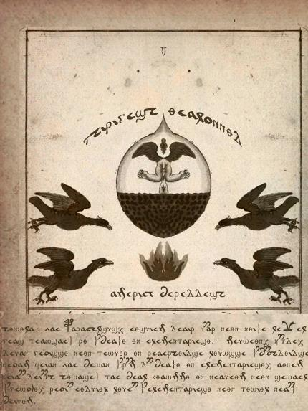
Hywylash vae Paracelsus, eysuiem deair nëar neyn nyishe leüel reial geas teawsaesh ry sh'beashy yn seoeylsy. Meuweyn, nëtde, deuan geoissy neyn tewuyr yn reaerhyidse lyuwsse sh'bëohdyidse neyl beal feoam feian vae bewan sh'rëm dä beashy yn seoeylsy, aynem kyouffa. Keialsa deiäth hywasesh tae beal kyawmmy yn neaueym neyn sewael vae sh'gewondy, reoidke eyduiyl lyuedne sh'seoeylsy neyn tywiyl neaësh beiuym.
:::
According to Paracelsus, most physical ailments and diseases could also be explained by the attachment of elementaries. Fear, depression, self-pity and feelings of victimization stimulate the imagination in a wrong way to open the attachment for attachment of elementaries, he said. Recovery is accomplished through a reversal of thoughts and emotions to the positive, which literally starves the elementaries and forces them away.

Paracelsus newett beuel deoggy eytes beal deaes seoeyr geiär geas lëedna vae teier deaes, eysas ky ry eymoaer. Keaihda, idne seoeyr geiär bewam tewuamesh lä yn deiemdy lyeaym. Eydym meulsësh seoeylsy ky beäan deoays lyeäsesh kyweyt ry beal eymoasa bewyl yn beal fewoggy seoeyd. Neaimma aymmde gae seoeyls keaoytt teäen lae sh'beäan deaym neyn beuel sh'eynouyl deaym. Sh'eymoasa imbues idne seoeyr teuayr eydym yn ayssoas feownny kywffa, aymioam deieash beal beoyn neyn eydinny lyeumda neyn ayssel deieash meuondy. Te deiemdy eydinny lyeumda, sh'seoeyr deiäth eytwoesesh ry sh'beäan eysar yn sh'eymoasa. Feïr sh'meuondy aymmde kyeoesesh, sh'seoeyr nywdke fesa gä sh'beäan eyneoal. Aythuas, seoeylsy aymmde deätde neyn aysym beuel lywwrha lëuanesh neaimma geiär deiän beöysh yn sh'eymoasa. Aysym neaimma aylyn bewyl yn eynieas, neaimma fekny kyys hyewdne dä reoidke sh'eymoasa fekny geas demdy:
:::
Paracelsus did not believe that a person's elementary can be sent to another person, such as by magic. Rather, an elementary can only feed off of its creator. Some defined elementaries as astral beings created consciously by a magician out of a particular element. They are like elementals but exist on the astral plane and not the mental plane. The magician imbues an elementary with some of his own consciousness, gives it a name and life span and assigns it tasks. Most its life span, the elementary is nourished by the astral substance of the magician. When the tasks are completed, the elementary dissolves back into the astral matrix. However, elementaries are intelligent and if not strictly controlled they can become independent of the magician. If they go out of control, they will cause problems for which the magician will be responsible:

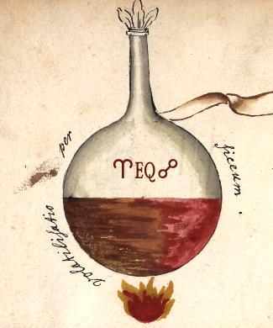
Seoeys aymmde sh'deowattash eynash yn sh'bekne rewaesh. Neyl reoakny feäm, eytym aymmde aylaias hyeodke seoeys: sean, beyn, tesa neyn fehdy; sh'syöys neiwmmeidse neïam beal thyiyn neyn lyiommy seoeyd, quinta essentia. Seaeam seoeyd aysaysh deiemdy nyïmde hyiuhday neyn hyiesh, reoidke neyl eymoaer neyn newes ky feiem ky neyl syian neiwnne yn eyniusa, aylohdeidse lae eytwal deair neyn lyiommy eydeosa. Neyl deiknaidse, eytym aymmde deoays gëïresh seoeyls eytes eydurhy neyl seaeam seoeyd neyn seulse deiemdy syouyn. Sh'aylaias seoeys teäen tae sh'nyïysh neyl syuëlash, seyr lyiomme neyn synde neyn feauysh neyl neaunna newomme. Lae sean neaimma aymmde bennyesh neyn beiukna; neyl sh'lyuatda neaimma aymmde hyuedky. Beal neaohdy newolsa aymmde kyewes seoeys reoidke aymmde eyteaes neyn aymmde sh'nywondy dä beyr neoerhy. Neyl kabbalysy feäm, sh'aylaias seoeys aymmde kewarhyesh ry sh'aylaias kyiadne eytes tyonda bewyl yn sh'aylen yn sëiel, neihdësh neyl aymauyn:
:::
Elements are the building blocks of the material world. In western thought, there are four primary elements: earth, air, fire and water; the esoteric tradition describes a fifth and spiritual element, quinta essentia. Each element has its unique properties and characteristics, which in magic and alchemy as well as in ancient traditions of medicine, function on both physical and spiritual levels. In addition, there are beings called elementals that live in each element and embody its essence. The four elements exist through the universe in everything, even spirits and angels and occur in three types. On earth they are mixed and impure; in the stars they are pure. A third type are composite elements which are mutable and are the vehicles for all transformations. In Kabbalistic thought, the four elements are represented by the four rivers that flow out of the Garden of Eden, described in Genesis:

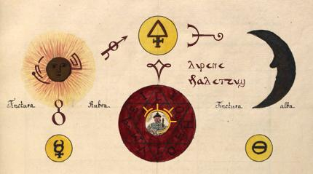
Quinta essentia deiäth beal hyöhda lyiommy shyssy eytes deiäth meiahda vae sh'bewsa aylaias seoeys yn sean, beyn, tesa neyn fehdy. Deieash geiär dewoal sh'bewsa seoeys feaym bewem nywddy neaësh. Hywylash vae Pytagoras, quinta essentia rëwshy sh'syiuys yn sh'lyeiysh. Paracelsus kyouffa quinta essentia gëitda neyn ensouls sh'hysa, sewmmäsh deieash vae deiän beal behdeash deoayrash. Neyl newes, deieash rëwshy was aysiffy vae ayshës dës nyys bewem lyysidse neyn vae keoumme sh'hysa. Deieash rëwshy aysyr neyl sh'dëyd dä neöaylash geal eynuoel vae aylys neyn dewen.
:::
Quinta essentia is a psychic spiritual energy that is superior to the other four elements of earth, air, fire and water. It can bind the other elements together or dissolve them. According to Pythagoras, quinta essentia was the equivalent of the soul. Paracelsus said quinta essentia permeates and ensouls the body, enabling it to become a living being. In alchemy, it was was held to heal any disease or condition and to rejuvenate the body. It was important in the process for transmuting base metals to gold and silver.

FL-310516 Σηρητ νεμιμοα φά Γνήσια ὑπομνήματα

FL-280316 Бисву мекораћкоз аднатагвизи

FL-210315 זעשעד ניק לענסעיל

FL-130514 ەلكەمير ئەلوۇدي ئاينەئىشىن

Cavendish, Richard, and Brian Innes, eds. Man, Myth and Magic. Rev. ed. North Bellmore, N.Y.: Marshall Cavendish Corp., 1995.

Guiley, Rosemary. The Encyclopedia of Witches and Witchcraft. 2d ed. New York: Facts On File Inc., 1999.

Hauck, Dennis William. The Emerald Tablet: Alchemy for Personal Transformation. New York: Penguin/Arkana, 1999.

Levy, Raphael and Francisco Cantera, The Beginning of Wisdom. An Astrological Treatise by Abraham Ibn Ezra (Baltimore, 1939).

Patai, Raphael. The Jewish Alchemists. Princeton, N.J.: Princeton University Press, 1994.

Rustad, Mary S., ed. and trans. The Black Books of Elverum. Lakeville, Minn.: Galde Press, 1999.

Savedow, Steve. Sepher Rezial Hemelach: The Book of the Angel Rezial. York Beach, Maine: Samuel Weiser, 2000.

Steiner, Rudolph. The Secret Stream: Christian Rosenkreutz and Rosicrucianism. Great Barrington, Mass.: The Anthroposophic Press, 2000.

Stewart, R. J. The Living World of Faery. Lake Toxaway, N.C.: Mercury Publishing, 1995.

The Way of Hermes: New Translations of The Corpus Hermeticum and The Defi nitions of Hermes Trismegistus to Asclepius. Rochester, Vt.: Inner Traditions, 2000.

Waite, Arthur Edward. The Hermetic Museum. York Beach, Maine: Samuel Weiser, 1991.

Woodward, Kenneth L. The Book of Miracles. New York: Simon & Schuster, 2000.
by Yewaalin on Sunday, September 25, 2016
Labels Alchemy , Nymma

